| FULL LEGAL NAME | **LOCATION (COUNTRY)** | **EMAIL ADDRESS** | **MARK X FOR ANY NON-CONTRIBUTING MEMBER** |
| --- | --- | --- | --- |
| **Shong Xian Lee** | **Singapore** | **shongxian5601@gmail.com** |  |
| **Emmanuel Hansingo** | **Zambia** | **emmanuel.hansingo@gmail.com** |  |
| **Ketty Muwowo** | **Zambia** | **kettymuwowo@gmail.com** |  |

| **Statement of integrity:** By typing the names of all group members in the text boxes below, you confirm that the assignment submitted is original work produced by the group (excluding any non-contributing members identified with an “X” above). | |
| --- | --- |
| **Team member 1** | **Shong Xian Lee** |
| **Team member 2** | **Emmanuel Hansingo** |
| **Team member 3** | **Ketty Muwowo** |

| Use the box below to explain any attempts to reach out to a non-contributing member. Type (N/A) if all members contributed.  **Note:** You may be required to provide proof of your outreach to non-contributing members upon request. |
| --- |
|  |

**Step 1: Part A**

| Days to maturity | Strike | Price | Type |
| --- | --- | --- | --- |
| 15 | 227.5 | 10.52 | C |
| 15 | 230 | 10.05 | C |
| 15 | 232.5 | 7.75 | C |
| 15 | 235 | 6.01 | C |
| 15 | 237.5 | 4.75 | C |
| 15 | 227.5 | 4.32 | P |
| 15 | 230 | 5.2 | P |
| 15 | 232.5 | 6.45 | P |
| 15 | 235 | 7.56 | P |
| 15 | 237.5 | 8.78 | P |

1.0 Introduction of Heston (1993)

The Heston model (1993) is designed to enhance the efficiency of Black-Scholes model. There are a few parameters which are the underlying price, mean reversion rate, long-term volatility, correlation between asset price and volatility, risk-free rate, maturity time, and strike price (Dunn, R., Hauser, P., Seibold, T., & Gong, G. 2015).

1.1. Heston (1993) Characteristic Function

The characteristics of Heston (1993) was shown as below:

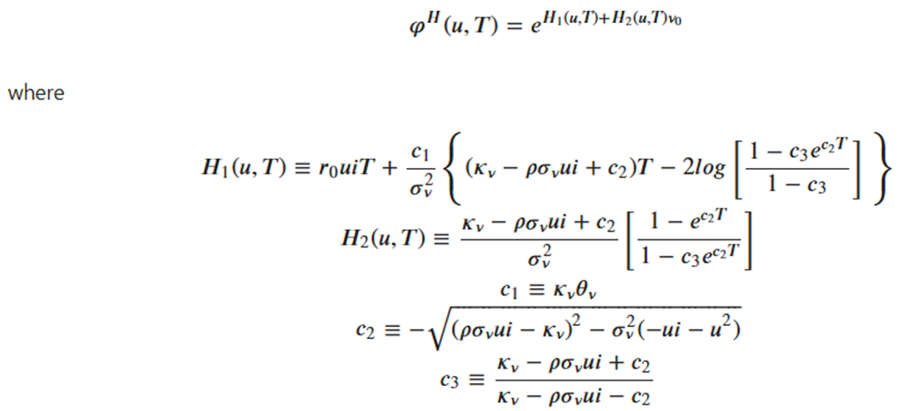

1.2 Integral value in Lewis (2001)

The following step is determined the integral value in Lewis (2001) method. The formula can be referred to as:

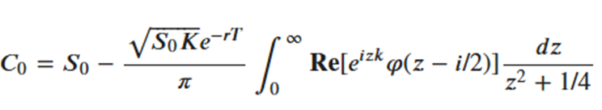

To deal with mean square error, the approach of Lewis (2001) was adopted that referred to Fourier transform methods.

1.3 Output

Both call and put option were using the similar Heston parameters of :

1. kappa_v = 1.5

2. theta_v = 0.02

3. sigma_v = 0.15

4. rho = 0.1

5. v0 = 0.01

Given information of underlying price: $232.90, risk free rate 1.5%, 250 days of total 1 year trading days. The call option price using Heston model is showed as below:

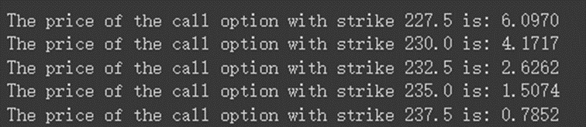

The maximum number of evaluations has been ignored by importing the ignore function. The parameter that going through the Lewis process (2001) are:



Based on the line graph, it shows a good fit of the model in calculating the call option price.

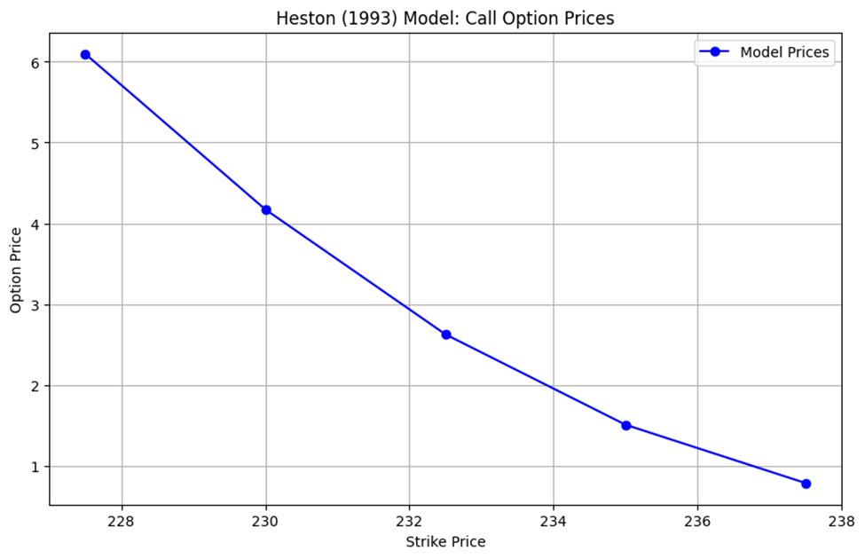

The price put option of the European put option are:

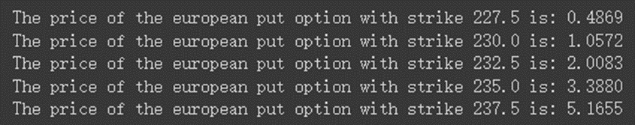

The price put option becomes expensive when the strike price is higher than the underlying price. It is using the put-call parity method to put the price option.

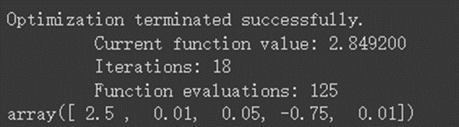

A calibration process has been done to determine the actual parameters which are 2.5, 0.01, 0.05, -0.75, 0.01, kappa, theta, sigma, rho, and variance, respectively.

A good fit of model prediction has shown from the Heston model.

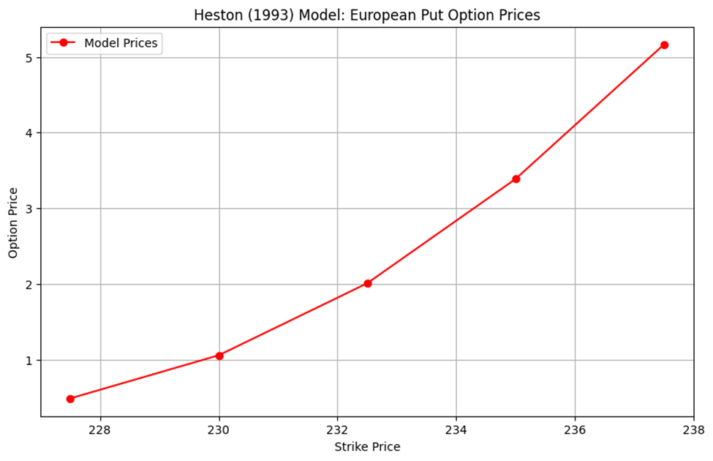

**Step 1: Part B - Carr-Madan (1999) Pricing Approach**

The Carr-Madan approach is an option pricing method that uses fast fourier transforms to evaluate option prices. It is especially useful for models that have known characteristic functions such as the Heston(1993) model.



Where $φ$ in this case represents the characteristic equation of the model.

**Parameters Obtained**

The parameters obtained using the Carr-Madan Approach were as follows:

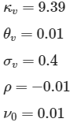

These parameters were tested for a call option with a maturity of 15 days, strike of $227.5 and current underlying price of $232.9. The price of the call as determined from the Heston 93 model using the Carr-Madan approach with the above calibrated parameters was $9.96. This price represents a 5% price difference compared to the actual price on record; $10.52. The Put value of this option was determined to be $4.35 compared to the observed value of $4.32, this represents a 0.6% difference between the market and the model.

**Calibration Approach**

Since the model being considered (Heston 93) is not a combination of different models it does not require parameters to be calibrated in different segments. The process was as follows:

* The characteristic function of the log price in the Heston model was created
* The Call value function was created to evaluate the integral of the Heston characteristic equation using fast fourier transforms (FFT).
* An error function which used the mean squared error MSE was created in order to minimize the error between model values and observed values during calibration with a min MSE of 100
* The full calibration was then done in two stages. The first stage used the brute force approach in order to scan sensible regions of the search space to get a faster convergence. Afterwards, a finer method was used on the second run to look deeper into the promising results for a finer convergence.
* A plot was then created to visually display the performance of the calibration compared to the market values.

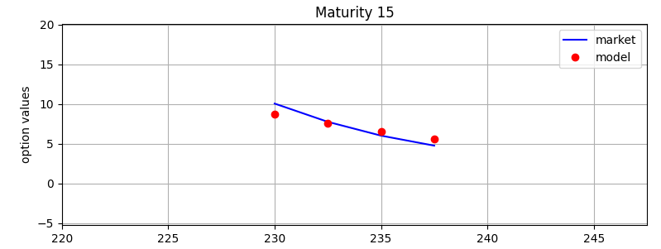

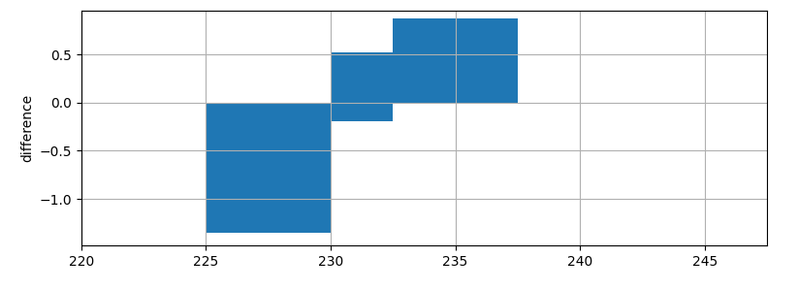

**Difference in Parameters**

Here are some of the potential reasons for differences in parameters:

* The parameters used in the Fast Fourier Transform (FFT), such as the number of points and the dumping value, can influence the accuracy and stability of the results. This coupled with the fact that the methods did not both use fast fourier transforms means that it is not possible to prevent this by matching the dumping value since one method does require one at all.
* The choice of minimum MSE could also factor into the difference in the parameters as this is used to determine the tolerance of model predictions compared to the market observations.
* The choice of whether calibration is done with both Calls and Puts or just one of the two. This can determine how much data is available for calibration and how closely the model can match the market for both calls and puts.

**Step 1: Part C - Pricing the Asian Call Option**

An Asian Option, also known as average Option is a type of derivative whose payoff depends on the average price of an underlying asset over a particular period. Asian options allow the buyer to purchase or sell the underlying asset at the average price as opposed to the spot price.

The Asian call payout is given by:

$C (T) = max(Avg(S(t)) - K,0)$, for $t = \{0, 1, . . . ,T\}$

Where $Avg(S(t))$ is the average Stock price for a period [0,T] and K is the strike price.

We made use of the Monte-Carlo Simulation to price the Asian call option with 20 days maturity. The following were the steps that were taken in the pricing of the Asian call option.

* Generated sample paths for the underlying stock price S(t) using the Calibrated Heston Model parameters obtained from Step 1 part (a) from Team Member A. The following were the optimal parameters obtained from the full calibration: $Optimal Parameters: [3.3, 0.13, 0, 0.67, 0.1 ]$
* Calculated the average stock price Avg(S(t)) over the 20-day period and computed the payoff of the Asian call option using the formula stated above for the Asian call option payoff.
* Discounted the payoff using the risk-free rate to obtain the option price in a risk neutral setting.
* Performed the Monte-Carlo simulation using 10,000 Simulations to obtain a robust estimate of the option price.

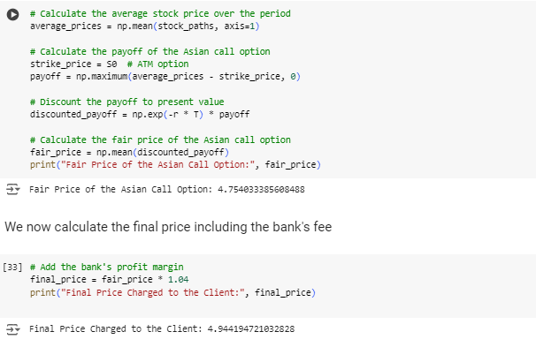

The Fair price that was obtained from the Monte-Carlo Simulation was $4.75 USD.

To obtain the final price for the client, we added a charge fee of 4%. Thus, the final price that the client is supposed to pay for this Asian call option is $4.94USD.

**Step 2: Part A**

Given information of underlying price: $232.90, risk free rate 1.5%, 250 days of total 1 year trading days.

| Days to maturity | Strike | Price | Type |
| --- | --- | --- | --- |
| 60 | 227.5 | 16.78 | C |
| 60 | 230 | 17.65 | C |
| 60 | 232.5 | 16.86 | C |
| 60 | 235 | 16.05 | C |
| 60 | 237.5 | 15.10 | C |
| 60 | 227.5 | 11.03 | P |
| 60 | 230 | 12.15 | P |
| 60 | 232.5 | 13.37 | P |
| 60 | 235 | 14.75 | P |
| 60 | 237.5 | 15.62 | P |

Call price: 60 days of maturity

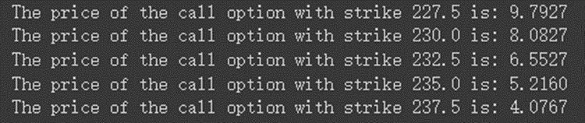

The model price of the call price is less than the given value in the excel sheet.

Full calibration process has been performed. The values are 2 (kappa), 0.04 (theta), 0.5 (sigma), -0.7 (correlation), 0.04, (volatility), 0.1 (lambda), -0.1 (mean reversion speed) and 0.2 (delta).

From the line graph and chart, it shows a good fit of the model.

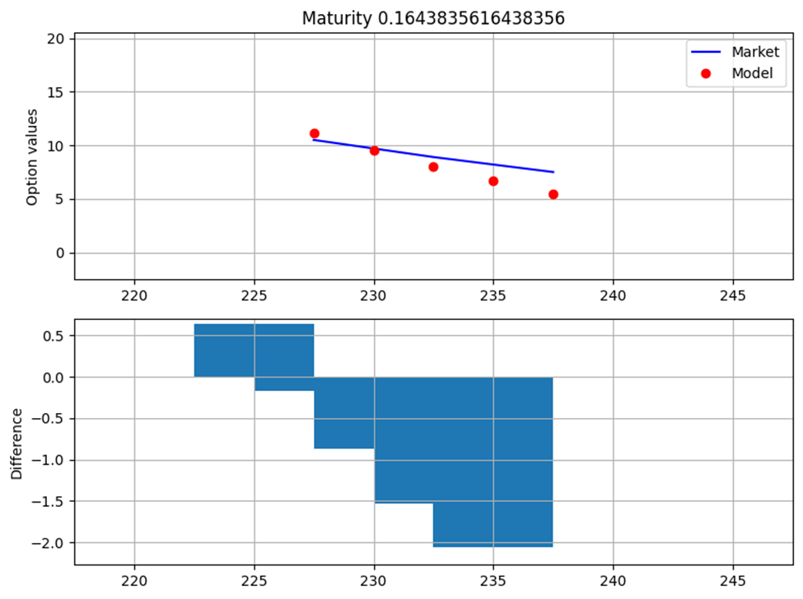

Put price: 60 days of maturity

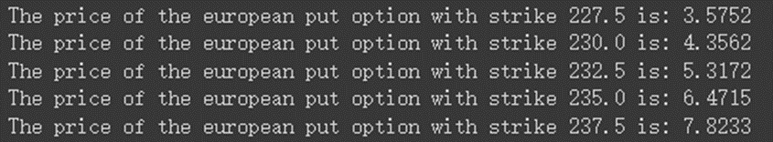

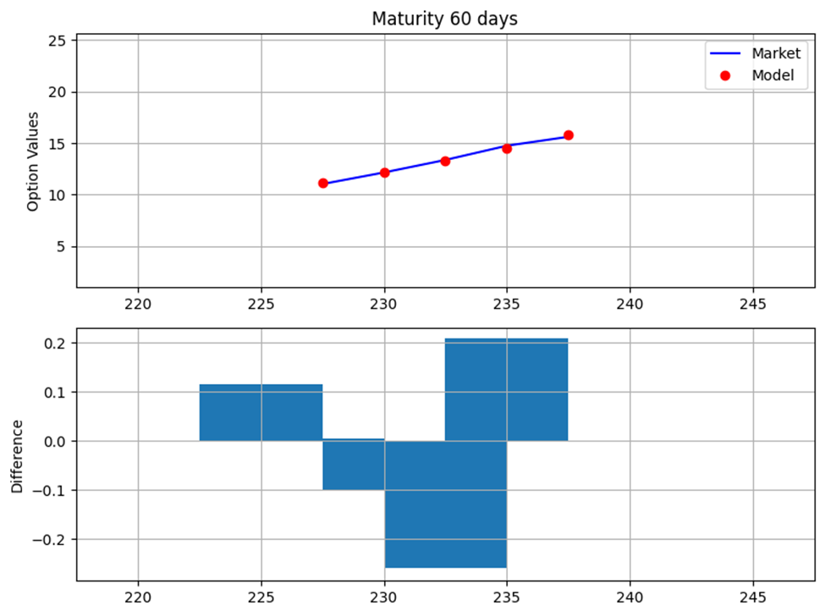

Based on the result, it describes the put option price and proves the model value is fit to the given market value of the put option.

**Step 2: Part B - Pricing the Asian Put Option**

In order to determine the price of an Asian Put we also have to consider the average price of the underlying asset just as we did for the Asian call. However, we have to make a small change to our payoff method. Instead of subtracting the strike price from the average asset price, we subtract the average price from the strike price. From this we then pick the greater value between the difference and zero:

$P (T) = max(K-Avg(S(t)), 0)$

For this particular instance we considered a Put option with a 70 day maturity and a strike that was 95% ($221.26) of the value of the starting price of the asset ($232.9). We simulated the price evolution of the asset’s price over the next 70 days using the Heston model. This simulation method uses the monte carlo approach which involves generating a large number of random samples from a probability distribution to model the uncertainty in a system. The price simulation then allowed us to obtain the average price of the asset during the maturity period in order for us to use it to get the fair price of the Asian put option. We found that the average price of the asset was greater than the strike price and this meant that we had a negative difference between the strike and the average price. This result meant that the final value of the put option was zero ($0). With a strike value less than the initial asset price, this option started Out of the money the result is not surprising since the calibration produced a $σ_{ν}$ of 0.0 and a low $θ_{ν}$ of 0.12, meaning that there was very little volatility in the volatility of the underlying asset giving it some stability over the time period and ensuring that the average price of the asset remained greater than the out of the money strike.

**Step 2: Part C - 60 day maturity Instrument calibration using the Heston Model with jumps (Bates, 1996 Model).**

Using the given Options data set, we performed the Bates Model calibration. The model was calibrated using a 60-day maturity time period. The following were the steps that were taken in the Bates calibration.

* Loaded the data set into a panda data frame. The data frame consisted of the following columns: Days to maturity, Strike, price and Type.
* Selected the options near the ATM to take into account in our calibration procedures and Filtered the data set for call options with 60 days to maturity. The time-to-Maturity (T) and short-rate (r) were also added to the data frame.
* Obtaining the calibrated parameters from the calibration of Heston in step 1 part (a).

Optimal Parameters: kappa_v = 3.2962, theta_v = 0.1299, sigma_v = 0.0000, rho = 0.6686, v0 = 0.1037

We then made use of these parameters to calibrate the jump component of the model.

* Performed the Calibration of the jump component using the Bates model parameters and functions defined in the python notebook. The following were the functions considered: Error function (B96_full_error_function) which was used to calculate the Mean squared error (MSE) between model-predicted option price and the actual market price. The Bates Model call value function (B96_call_value) was used to compute the call option price based on the Bates Model parameters and the parameter calculation function (B96_calculate_model_values) was used to compute the model-predicted values for the given parameter vector.
* Performed the calibration by minimizing the error function and found the optimal parameters. This calibration was performed using the B96_calibration_full function.

After performing the short and full calibration, the final calibrated parameters obtained were;

Full parameters to 5 decimal places: ['5.57919', '0.12016', '0.00001', '0.93145', '0.13784', '0.01400', '-0.01049', '0.00001']

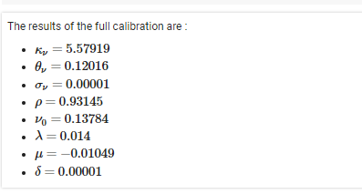

From the line graph below that was plotted using the calibrated parameters, a good fit of the model was evident.

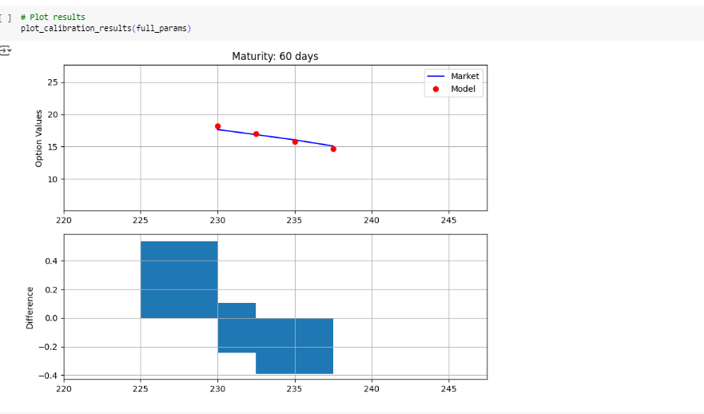

**Step 3: Part B - Simulating the Euribor 12-Month rates**

Using the Calibrated CIR (1985) Model parameters obtained from Step 3 part A, we performed 100,000 Simulations using the Monte-Carlo simulation function below, in order for us to simulate the 12-month Euribor rate over a 1-year period.

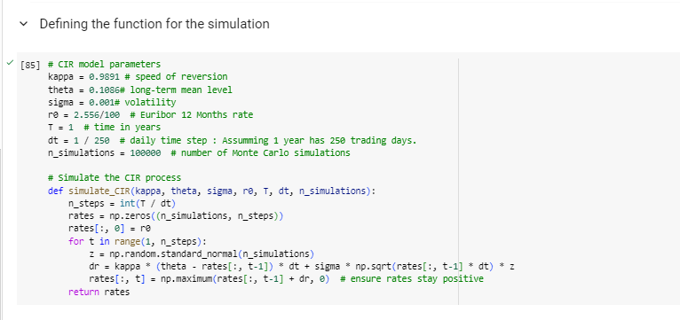

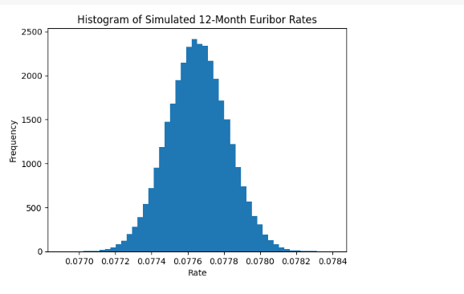

We selected a 95% confidence level to determine the maximum and minimum range of the 12-month Euribor rate. Below were the results of the confidence level computation.

Confidence Interval (95%):

Minimum rate: 0.07733

Maximum rate: 0.07798

The expected value expected value of the 12-month Euribor rate in 1 year was computed using the code provide below:

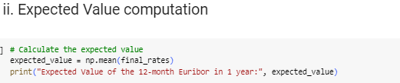

Expected Value of the 12-month Euribor in 1 year: 0.0776543491717462

(iii)  **Discussing the impact on pricing products**

The current 12-month Euribor rate stood at 2.556% (0.0256). The expected Euribor rate was 0.0521 percentage points higher than the current rate. This expected increase in the Euribor rate suggested that borrowing costs were likely to rise, which could potentially lead to higher costs for products and services linked to this benchmark interest rate.

**References**

Dunn, R., Hauser, P., Seibold, T., & Gong, G. (2015). Estimating Option Prices with Heston’s Stochastic Volatility Model. Valparaiso University. Retrieved at:<https://www.valpo.edu/mathematics-statistics/files/2015/07/Estimating-Option-Prices-with-Heston%E2%80%99s-Stochastic-Volatility-Model.pdf>

Chen James, Vanilla Option: Definition, Types of Option, Features and Example, April 21, 2022, <https://www.investopedia.com/terms/v/vanillaoption.asp#:~:text=A%20vanilla%20option%20is%20a%20financial%20instrument%20that,option%20that%20has%20no%20special%20or%20unusual%20features>.

STOCHASTIC VOLATILITY: HESTON, DERIVATIVE PRICING, MODULE 7, LESSON 1

OPTION PRICING UNDER HESTON (MONTE-CARLO), DERIVATIVE PRICING, MODULE 7, LESSON 2

**https://www.investopedia.com/terms/a/asianoption.asp#:~:text=An%20Asian%20option%20is%20an,point%20in%20time%20(maturity).**